Generating Sequences

1. The six times table can be generated in two different ways:

A 6, 6 + 6, 6 + 6 + 6, 6 + 6 + 6 + 6, …
the first term is six, and the rule is add 6.

B | 1st term | 2nd term | 3rd term | n^{th} term
 | 6 × 1 | 6 × 2 | 6 × 3 | 6 × n (or 6n)

Which method would you use if you were asked to find the 100th term of this sequence? Explain your answer.

2. Both the methods above can be used if we want a spreadsheet to calculate the sequence for us. Match each spreadsheet below to the method it is using.

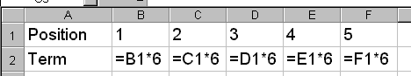
1

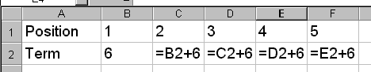
2

3. If you were asked to generate the 8 times table on a spreadsheet, show the two ways in which you could do this. You will need a template like this:

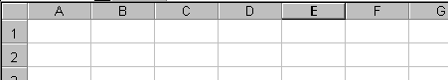

4. For each of the sequences below, choose one way in which you could use a spreadsheet to generate it, and write down in a template how you would do so.

- 4, 7, 10, 13, … | - 8, 10, 12, 14, … | - 48, 57, 66, 75, …
- 17, 14, 11, 8, … | - -6, -11, -16, -21, … | - 1, 1, 2, 3, 5, …

5. Swap your work with a partner, and use a spreadsheet to type in their answers to question 4. Show them how well they have done, and if there are any errors try to see why they have been made.

